Ex. No. : 01C Date: 02-02-2026
Register No.: 231701023 Name: S.V.Jashwanth

BMI Calculator
Aim
Create an app that calculates the Body Mass Index (BMI) based on user input for weight and height in EditText fields. The result is displayed in a TextView after pressing a Button.

Procedure:
- Open Android Studio and create a new project using Empty Activity.

- Choose Kotlin as the programming language.

- Design the layout with EditText fields for entering weight and height, a Button to calculate BMI, and a TextView to display the result.

- Open the MainActivity.kt file and connect all the UI components using findViewById.

- Write the logic to calculate BMI using the formula
BMI = weight / (height × height).

- When the user presses the Calculate button, the BMI value is calculated and displayed in the TextView.

- Run the application and check that the correct BMI is shown for the given inputs.

AndroidManifest.xml

<?xml version="1.0" encoding="utf-8"?>
<manifest xmlns:android="http://schemas.android.com/apk/res/android"
xmlns:tools="http://schemas.android.com/tools">
<application
android:allowBackup="true"
android:dataExtractionRules="@xml/data_extraction_rules"
android:fullBackupContent="@xml/backup_rules"
android:icon="@mipmap/ic_launcher"
android:label="@string/app_name"
android:roundIcon="@mipmap/ic_launcher_round"
android:supportsRtl="true"
android:theme="@style/Theme.BMICalculator">
<activity
android:name=".MainActivity"
android:exported="true">
<intent-filter>
<action android:name="android.intent.action.MAIN" />
<category android:name="android.intent.category.LAUNCHER" />
</intent-filter>
</activity>
</application>
</manifest>

Activity_main.xml

<?xml version="1.0" encoding="utf-8"?>
<LinearLayout xmlns:android="http://schemas.android.com/apk/res/android"
xmlns:app="http://schemas.android.com/apk/res-auto"
xmlns:tools="http://schemas.android.com/tools"
android:id="@+id/main"
android:layout_width="match_parent"
android:layout_height="match_parent"
android:background="#00ED3636"
android:backgroundTint="#FFFFFF"
android:orientation="vertical"
tools:context=".MainActivity">
<TextView
android:id="@+id/txtHeader"
android:layout_width="match_parent"
android:layout_height="114dp"
android:background="#034333"
android:fontFamily="@font/comic_neue_bold"
android:gravity="center"
android:text="BMI Calculator"
android:textColor="#4CAF50"
android:textSize="34sp" />
<EditText
android:id="@+id/txtWeight"
android:layout_width="match_parent"
android:layout_height="wrap_content"
android:layout_marginLeft="10dp"
android:layout_marginTop="20dp"
android:layout_marginRight="10dp"
android:ems="10"
android:fontFamily="@font/averia_gruesa_libre"
android:inputType="number|numberDecimal"
android:hint="Weight (Kg)"
android:textSize="24sp" />
<EditText
android:id="@+id/txtHeight"
android:layout_width="match_parent"
android:layout_height="wrap_content"
android:layout_marginLeft="10dp"
android:layout_marginTop="20dp"
android:layout_marginRight="10dp"
android:ems="10"
android:fontFamily="@font/averia_gruesa_libre"
android:inputType="number|numberDecimal"
android:hint="Height (cm)"
android:textSize="24sp" />
<TextView
android:id="@+id/txtResult"
android:layout_width="match_parent"
android:layout_height="wrap_content"
android:background="#4CAF50"
android:gravity="center"
android:text="Your Score"
android:textColor="#FFFFFE"
android:textColorLink="@color/white"
android:textSize="24sp" />
<Button
android:id="@+id/txtCalculate"
android:layout_width="match_parent"
android:layout_height="wrap_content"
android:layout_marginLeft="25dp"
android:layout_marginTop="40dp"
android:layout_marginRight="25dp"
android:fontFamily="@font/andada"
android:text="Calculate"
android:textSize="20sp" />
</LinearLayout>

MainActivity.kt

package com.example.bmicalculator
import android.os.Bundle
import android.widget.Button
import android.widget.EditText
import android.widget.TextView
import androidx.activity.enableEdgeToEdge
import androidx.appcompat.app.AppCompatActivity
import androidx.core.view.ViewCompat
import androidx.core.view.WindowInsetsCompat
class MainActivity : AppCompatActivity() {
override fun onCreate(savedInstanceState: Bundle?) {
super.onCreate(savedInstanceState)
enableEdgeToEdge()
setContentView(R.layout.activity_main)
val txtWeight=findViewById<EditText>(R.id.txtWeight)
val txtHeight=findViewById<EditText>(R.id.txtHeight)
val txtResult=findViewById<TextView>(R.id.txtResult)
val txtCalulate=findViewById<Button>(R.id.txtCalculate)
txtCalulate.setOnClickListener {
if(txtWeight.text.isEmpty() || txtHeight.text.isEmpty()){
txtResult.text="Please enter all values!"
return@setOnClickListener
}
val weight=txtWeight.text.toString().toFloat()
val height=txtHeight.text.toString().toFloat()
val heightm=height/100
val bmi=weight/(heightm*heightm)
val status=when{
bmi<18.5->"Underweight"
bmi<25->"Normal"
bmi<30->"Overweight"
else->"Obese"
}
txtResult.text="BMI: %.2f (%s) ".format(bmi,status)
}
ViewCompat.setOnApplyWindowInsetsListener(findViewById(R.id.main)) { v, insets ->
val systemBars = insets.getInsets(WindowInsetsCompat.Type.systemBars())
v.setPadding(systemBars.left, systemBars.top, systemBars.right, systemBars.bottom)
insets
}
}
}

Output

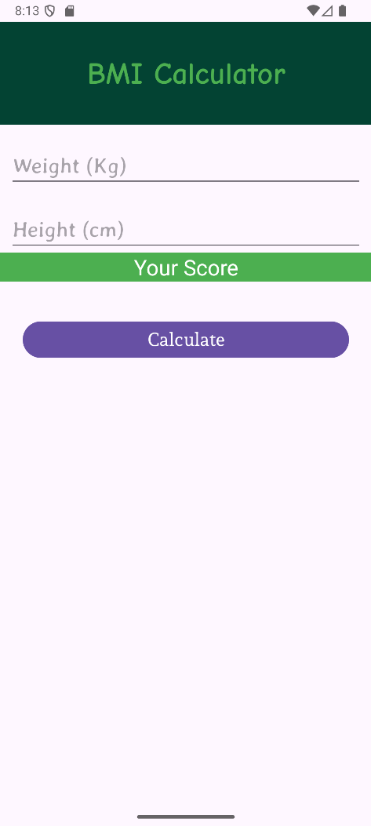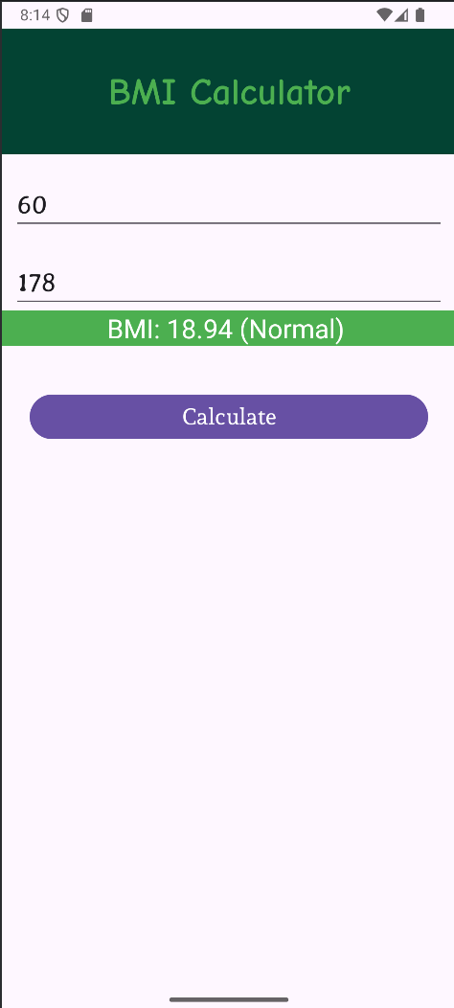

Result:
The application was successfully developed.
It calculates the Body Mass Index (BMI) based on the user’s height and weight and displays the result on the screen when the button is pressed.

